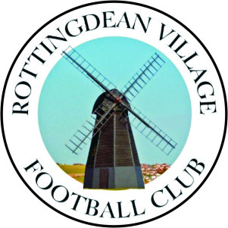

Rottingdean Village Football Club
Saturday 13TH April 2024
Kick off 3:00 pm
Southern Combination Football League
Division 2 League
ROTTINGDEAN VILLAGE
V
RUSTINGTON

Founded 1922 Reformed 1985

Ground
Rottingdean Football & Cricket Ground
Falmer Road, Rottingdean
Brighton, BN2 7DA
Telephone 01273 306436

Chairman Richard Cloake
General Secretary Clare Cloake
Youth Secretary Keith Meeres
Treasurer Nick Czolak
Youth Fixture Secretary Rick Wort

First Team Manager Russell Pannett

Club Contacts
General Secretary Clare Cloake
Mobile 07411 747605
Email clare@rottingdeanvillagefc.co.uk

Chairman Richard Cloake
Mobile 07963 938705
Email richard@rottingdeanvillagefc.co.uk

Youth Secretary Keith Meeres
Mobile 07803 899472
Email k.meeres@ntlworld.com
Good afternoon and welcome to Rottingdean.

We would like to welcome you all to the Rottingdean Sports Centre and to this division 2 league match.
.
Our visitors today are Rustington FC a very warm welcome to their players, officials and supporters. We hope you enjoy your short stay with us. We also extend a very warm welcome to the match referee Neal Saxton. We hope they enjoy their day with us.

We are very keen to sell more advertising boards, if you know of any company who you think might be interested, please let us know. The cost for new boards is £275 for one year or £325 for two years which includes the manufacture of the board. Existing boards are £75 for one year or £125 for two years.

Best of luck to both teams and we hope you all have an enjoyable game.

Please feel free to join us in the clubhouse, where food and drinks are on sale all day. We hope you all enjoy your time at Rottingdean and thank you for your support.

Southern Combination Football League
Division 2
League / Cup | Date | Home / Away | Opposing Team | Result | Win/ Draw/Lost
L | 26/08/23 | A | Southwater FC | 8 – 1 | Lost
L | 28/08/23 | H | Brighton Electricity FC | 0 – 1 | Lost
Cup | 09/09/23 | H | Ferring | 1 – 4 | Lost
L | 16/09/23 | A | Upper Beeding | 0 – 1 | Won
L | 23/09/23 | A | Bosham | 6 – 2 | Lost
L | 30/09/23 | A | Jarvis Brook | 3 – 2 | Lost
L | 07/10/23 | H | St Francis Rangers FC | 0 – 5 | Lost
L | 14/10/23 | H | Capel FC | 0 – 3 | Lost
L | 21/10/23 | H | Ferring | 1 – 3 | Lost
L | 25/11/23 | H | Upper Beeding | 1 – 6 | Lost
Cup | 02/12/23 | A | Bosham | 1 – 0 | Lost
L | 16/12/23 | A | Storrington | 1 – 0 | Lost
L | 30/12/23 | A | Brighton Electricity FC | 2 – 2 | Draw
L | 06/01/24 | H | Bosham | 0 – 5 | Lost
L | 13/01/24 | A | St Francis Rangers FC | 2 – 2 | Draw
L | 27/01/24 | H | Jarvis Brook | 1 – 3 | Lost
L | 03/02/24 | H | Southwater | 1 – 3 | Lost
L | 24/02/24 | A | Ferring | 3 – 3 | Draw
L | 16/03/24 | H | Storrington | 0 – 3 | Lost
L | 23/03/24 | H | Hailsham | 1 – 3 | Lost

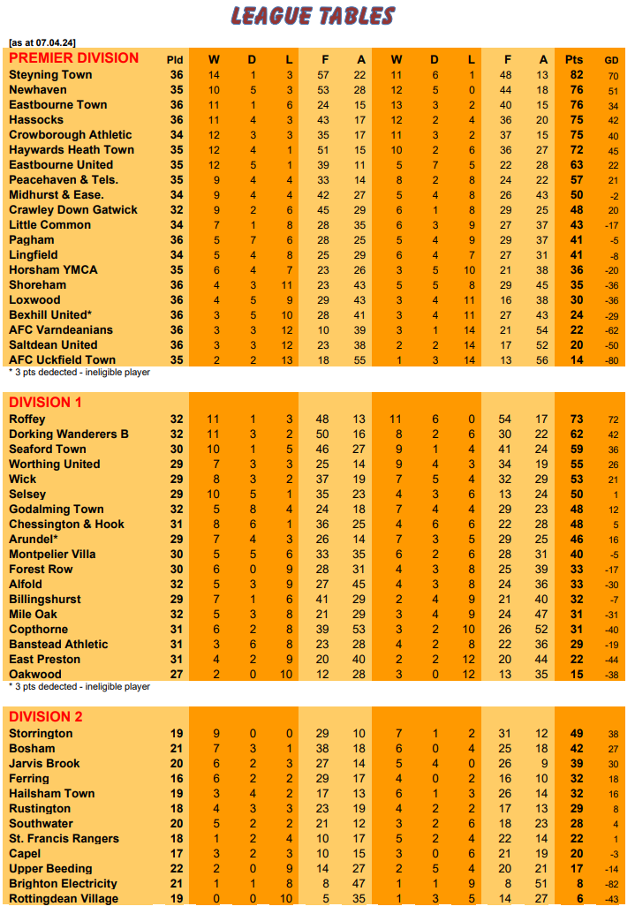
Rottingdean Village FC
Colours Red & Black Shirts, Black Shorts, Black socks

From

Craig Anderson  Sam Brice  Dominique Brown  Ryan Carse  Milan Donno  Shaheen Louhichi  Luke Stevens  James Purvis | Vadym Panov  Tshikume Phadagi  Alassane Sinayogo  Aimen Toumi  Tony Rybnikar  Bradleigh Vaughan  Kim Yeong Min  Bradley King

Manager Russell Pannett
Asst. Referee Mick Salsbury
Referee Neal Saxton

Rustington FC

Colours – Shirts Blue, Shorts Blue & Socks Blue

Manager
Spencer Vine
From
Adam Banfield  Carl Bennett  adam carlier  Matthew Carter  Guy Church  Jordan Dean Clark  Simon Clarke  Elliott Collett  Jonathan Cooper  Simon Corona  Danny Coughlan  Jamie Crouch  Sean Culley  Liam Da Costa  Chris Darwin  Ryan De Gruchy  Tom Donnelly  Alexander Duncan  Dave Evans  Harry Franks  Sam Gunn  Sean Harris-Hardy  Luke Huggett  Martin Lawrence  Regan Miles  Billy Nash  Jack Robert Roy Newhouse  Joe Onipede  Brandon Osbourne  Gary Peters  kai porter  Darren Prior | Liam Reynolds  Jake Sayers  Joseph Stakim  Jordan Thomas  Spencer Vine  Tom Wakeling  Ryan Warr  Shay Wiggans

ROTTO LOTTO FUNDRAISER

Are you feeling lucky
and interested in winning money?

Why not join our exciting Rotto Lotto!

First prize is 30% of the taking
Second prize 20%
Third 10%

The club will receive 40%

Entry is only £5 per month!
Standing Order forms are available
in the clubhouse

