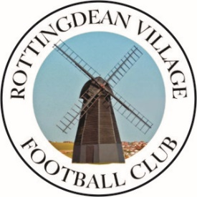
Rottingdean Village Football Club

Our Club Ethos
RVFC is a family football club that provides football for all within our local community.
Our youth section provides football for children of all ages and abilities in a safe, friendly, and positive environment.
As a club, we aim to:
- Deliver age-appropriate coaching to support long-term player development; improve players footballing skills, develop their physical, social and emotional skills so they are confident, competent, happy and respectful players.
- Encourage all players to try new things, to try their best and to make the most of their abilities.
- Offer a challenging but supportive environment where children can learn from their mistakes without undue pressure or fear of failure.
- Promote good behaviour and respect for others, through our Parent/ Spectator, Player and Team Officials (coaches) Codes of Conduct.
- Support competitiveness and a desire to win but we do not support winning at all costs nor at the expense of our core values.
- Promote our core values of: positivity, respect, support, encouragement, hard work, friendship, fairness and equality.
FA Charter Standard Accreditation
We are proud to be an FA Charter Standard Club which means we are the best place for people to play and enjoy football within our community. We prioritise safeguarding and welfare, training for our coaches as well as the values of The FA’s Respect programme. We demonstrate positive football environments where people experience their football in a safe, fun and inclusive environment.

